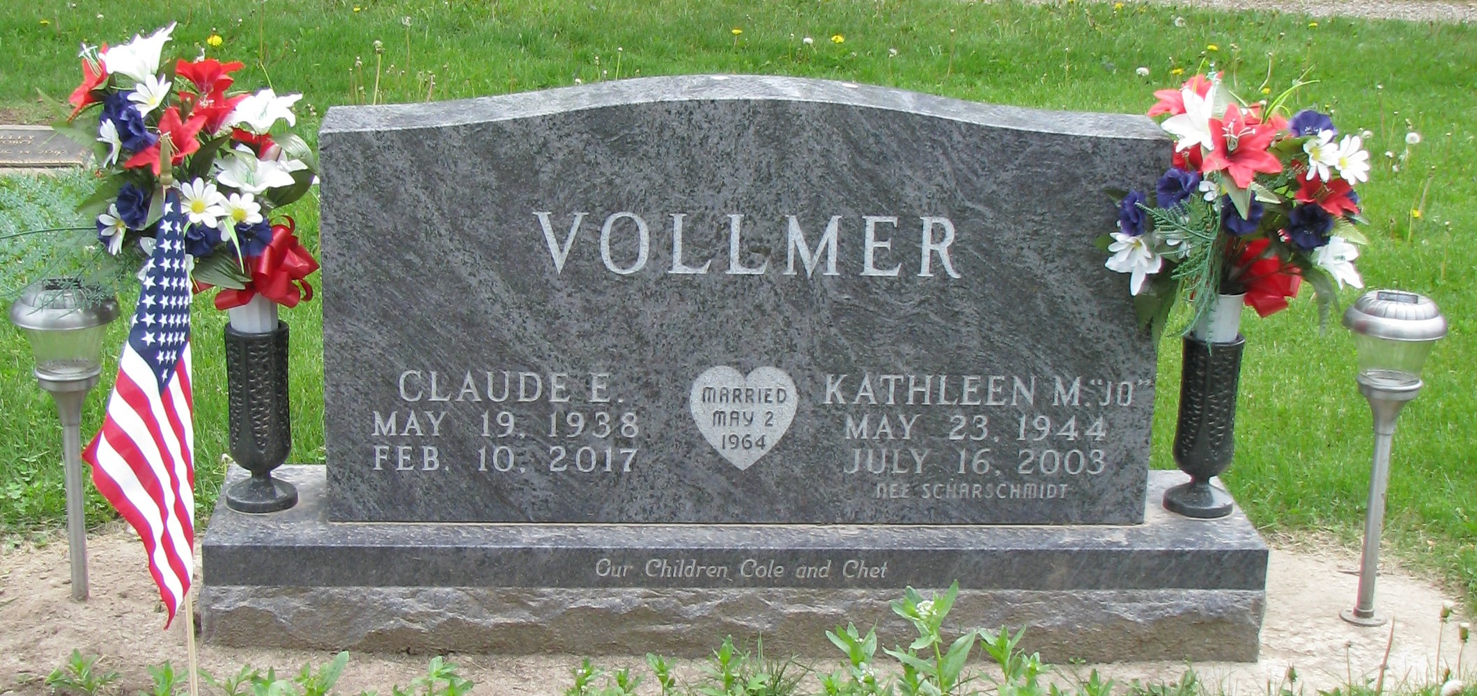
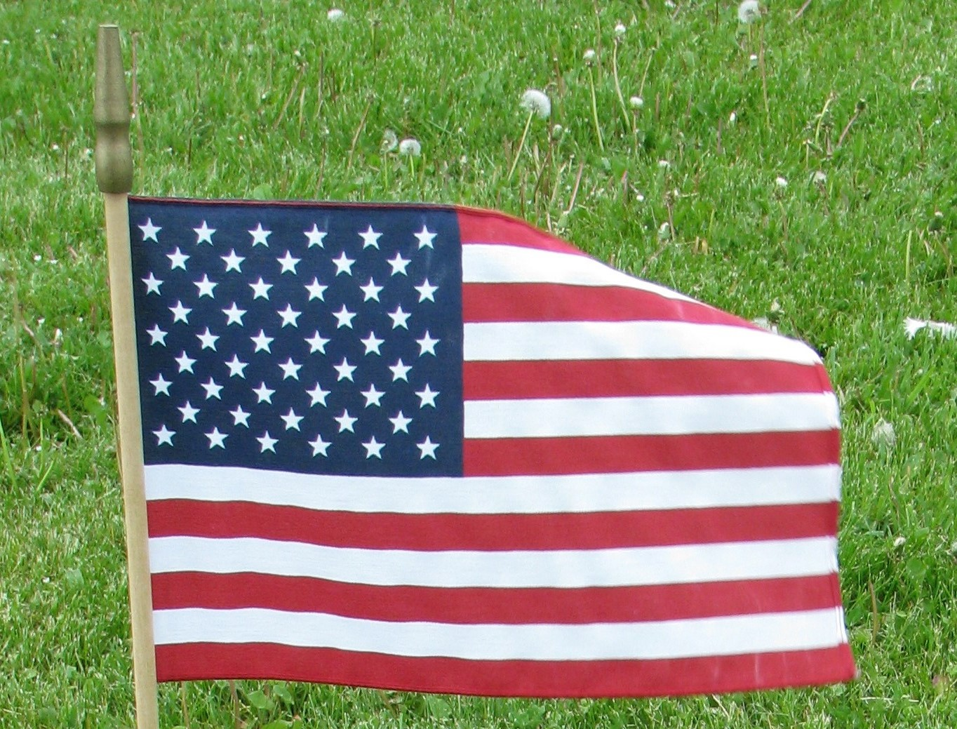

CLAUDE E. VOLLMER
Wisconsin National Guard
St. John’s Cemetery

